**Documentation of Company Network**



**Name: M Usman**

**Roll no: DS-014**

**Program: Data Sciences**

**Section: 5A**

**Subject: Computer Networks Lab**

**Initiate Company Network Overview**

This documentation provides a clear and simple description of the network designed in Cisco packet tracer for the exact purpose of the company "Initiate." Each part of the network is designed to connect different departments and ensure smooth communication and data sharing.

**Main Components of the Network**

**1. Central Router (Main Connection Hub)**

* Acts as the central device connecting all departments and rooms.
* Ensures all devices in the company can communicate with each other.

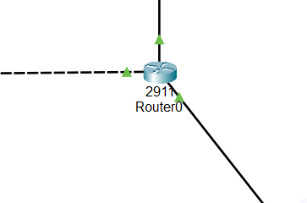

**2. Departments and Rooms**

**1. Server Room**

* **3 servers connected**
* Contains critical devices along the lines of:
  + **File Server:** Stores company files and documents.
  + **Web Server:** Hosts the company website or web-based applications.
  + **Backup Server:** Keeps backups of important data.
* **IP Range:** 192.168.1.10
* **IP Allocated using DHCP**
* **Reserved Ips:** 192.168.1.1 – 192.168.1.10

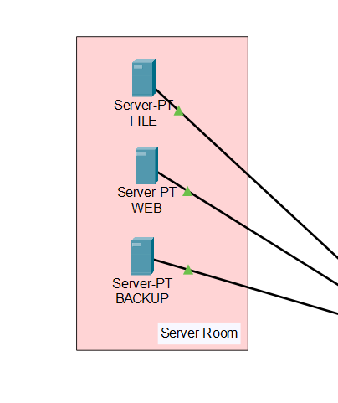

**2. Sales Room**

* 5 PCs 1 Printer and 1 Sales Head Laptop connected
* Includes PCs used by the sales team to manage client data and sales operations.
* Connected to the central router.
* **IP Range:** 192.168.3.1
* **IP Allocated using DHCP**

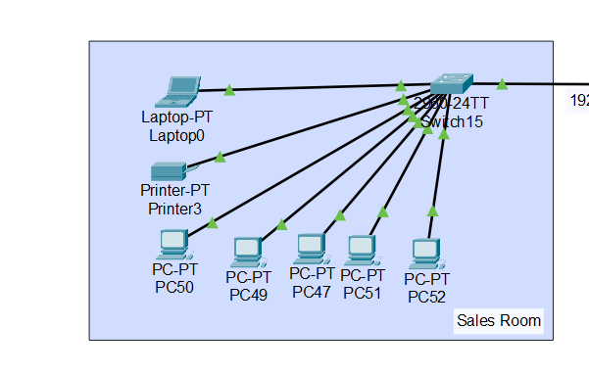

**3. Finance Room**

* 4 PCs 1 Printer and 1 Finance Head Laptop connected
* Used by the finance team for the exact purpose of managing accounts and financial records.
* **IP Range:** starts from 192.168.4.0 if reserved will not be allowed
* **IP Allocated using DHCP**

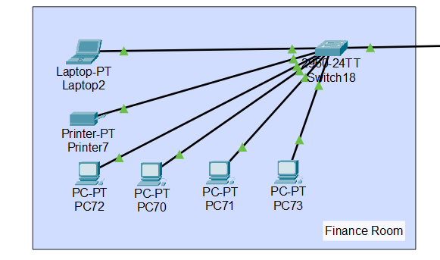

**4. Marketing Room**

* 5 PCs 1 Printer and 1 Marketing Head Laptop
* Equipped with PCs for the exact purpose of creating marketing materials and handling campaigns.
* **IP Range:** starts from 192.168.4.0 if reserved will not be allowed
* **IP Allocated using DHCP**

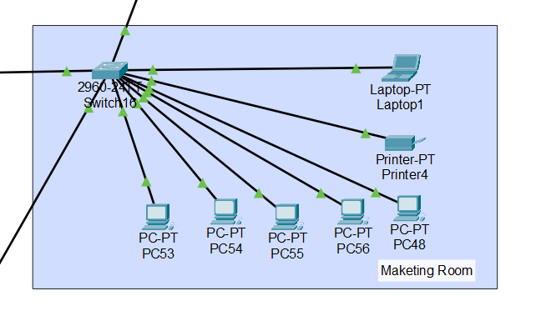

**3. Research Room**

* 4 PCs 1 Printer and 1 Research Head computer
* Used by the Research team for the exact purpose of managing how company can grow faster and financially better
* **IP Range:** starts from 192.168.4.0 if reserved will not be allowed
* **IP Allocated using DHCP**

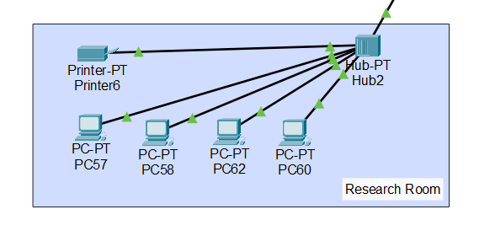

**5. Operations Management Room**

* 4 PCs 1 Printer and 1 Marketing Head Laptop
* Contains devices for the exact purpose of managing company operations and support systems.
* Includes printers and PCs.
* **IP Range:** starts from 192.168.5.0 if reserved will not be allowed
* **IP Allocated using DHCP**

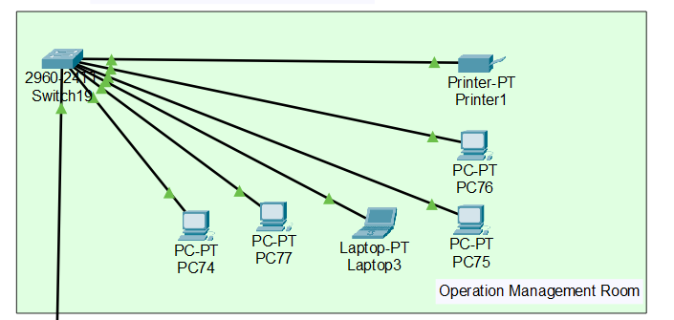

**6. IT Department**

* 4 PCs 1 Printer
* Houses IT team devices and printers.
* Manages network configurations and troubleshooting.
* **IP Range:** starts from 192.168.1.0 if reserved will not be allowed
* **IP Allocated using DHCP**

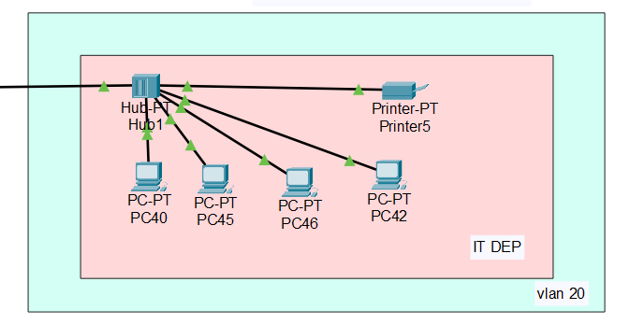

**7. HR and CEO Rooms**

* **HR Room:** For the exact purpose of managing employee data and recruitment processes.
* **CEO Room:** Includes the CEO's system for the exact purpose of overseeing company activities.
* **IP Range:** starts from 192.168.1.0 if reserved will not be allowed
* **IP Allocated using DHCP**

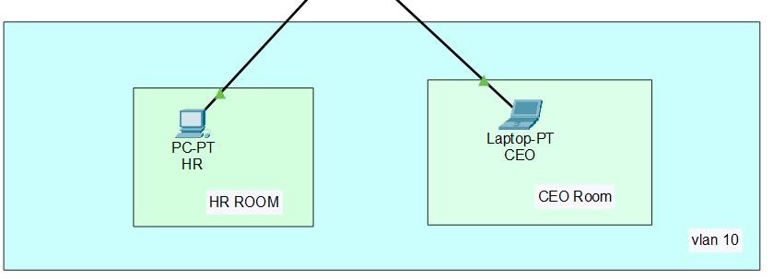

**3. Key Devices in Each Room**

* **PCs:** Workstations for the exact purpose of employees.
* **Printers:** Shared printers for the exact purpose of document printing.
* **Switches:** Used to connect multiple devices within the same room.
* **Router:** Connects each room to the main network.

**Network Flow**

1. Data flows between all rooms through the **central router**.
2. Each department is isolated by its IP range for the exact purpose of security and organization.
3. Shared resources, such as servers and printers, are accessible based on department needs.

**Benefits of the Design**

* **Centralized Management:** Easy to monitor and control the entire network.
* **Departmental Organization:** Each department has its own dedicated network.
* **Scalability:** Can add more rooms or devices without major changes.
* **Security:** Isolated IP ranges prevent unauthorized access between departments.

**Communication in the Network**

The network is designed to enable smooth and efficient communication between departments, devices, and servers. Here's how it works:

**1. Communication Between Departments**

* All departments (Sales, Marketing, Finance, IT, Operations Management, HR, and CEO) are connected to a **central router**.
* The central router ensures that data can flow between departments securely and efficiently.
* Each department has its own **IP range**, so they can communicate internally while being organized.

**2. Communication with Servers**

* All departments can access the servers in the **Server Room** through the network:
  + **File Server:** For the exact purpose of storing and sharing documents and files.
  + **Web Server:** For the exact purpose of hosting internal and external web applications.
  + **Backup Server:** For the exact purpose of secure backup and recovery of data.
* Communication is handled using specific protocols (e.g., file-sharing protocols, web protocols) based on the service.

**3. Communication Between Devices**

* **Within a department:**
  + Devices (PCs, laptops, and printers) within the same department are connected via **switches**.
  + Employees in the same department can share files and printers without using the central router.
* **Departments:**
  + Devices in different departments communicate through the central router.
  + For the exact purpose of example, the Marketing team can send data to the Finance team via the router.

**4. Internet Access**

* Internet access is shared across the network through the central router.
* Each department can access online resources as needed for the exact purpose of their tasks.
* The IT department manages internet security (e.g., firewalls) to protect the network.

**5. Communication for the exact purpose of Printing**

* Shared printers are in departments along the lines of IT, Operations Management, and Finance.
* Employees can send print jobs from their PCs to printers over the network.

**6. Communication Security**

* The network uses separate IP ranges for the exact purpose of each department to **isolate traffic**.
* This ensures sensitive data stays within the relevant department.
* IT manages security policies to prevent unauthorized access.

**How Data Flows: An Example**

Let’s say a Marketing employee needs to send a sales report to the Finance team:

1. The employee sends the file from their PC.
2. The file goes to the central router.
3. The router for the exact purpose of wards it to the Finance department’s network.
4. A Finance employee receives the file on their PC.

Here is how the CEO and HR can send messages to any member of any department directly

**Vlan 10 and Vlan 20:**

Vlans are created so that the CEO and HR can access the department of IT if there is any kind of problem that occurs.

**Vlan 10:**

Vlans 10 consists of 2 computers 1 is CEO and 1 for the HR, CEO or HR can access each other Computers if one is not there.

**Vlan 20:**

Vlans 10 consists of 4 computers, and they can access each other Computers if one is not there.